**ETL Document :**

**Dimensional Model:**

**Cleaning & Transformation of Austin Datatset:**

1. Converting Crash_date column to crash_date_actual by removing timeframe from it since it originally contained date as well as time.
2. Add distinct Record ID for each record before it is normalized.
3. Parse only the “Hour” from crash_time and create a new integer datatype column to store it.
4. Check for the null values of all the columns and remove string nulls replacing it to “NA” and remove integer column nulls replacing it to “0”.

1. Concatenate contribution factor ID 1 and 2 columns using this expression in order to normalize them later.

1. Use component Tnormalize to normalize the columns units_involved and concatenated contribution_factor_id.
2. Map the related contribution_factor with the values in the mapping document and extract the generalized values from the mapping document as a new column as we have to keep the id and the contribution factor description same for all the 3 datasets later.
3. Later apply upper case and trim functions to those column values which you will need to look up later.
4. Add columns DI_CreatedDate, DI_WorkflowName and DI_SourceID to the table.

Complete Workflow Screenshot:

**Cleaning & Transformation of Chicago Datatset:**

1. Split crash_date into crash_Date_string and crash_time_string by converting it into string first.
2. Add distinct Record ID for each record before it is normalized.
3. Check for the null values of all the columns and remove string nulls replacing it to “NA” and remove integer column nulls replacing it to “0”.

1. Concatenate primary_contribution_cause and secondary_contribution_cause columns in order to normalize them later.

1. Use component Tnormalize to normalize the concatenated column contributing_cause.

1. Extract only the “Hour” from crash_time_string and create a new integer datatype column to store it.
2. Map the related contribution_factor with the values in the mapping document and extract the generalized values from the mapping document as a new column as we have to keep the id and the contribution factor description same for all the 3 datasets later.
3. Later apply upper case and trim functions to those column values which you will need to look up later.
4. Add columns DI_CreatedDate, DI_WorkflowName and DI_SourceID to the table.

Complete Workflow Screenshot:

**Cleaning & Transformation of NewYork Datatset:**

1. Add distinct Record ID for each record before it is normalized.
2. Check for the null values of all the columns and remove string nulls replacing it to “NA” and remove integer column nulls replacing it to “0”.

1. Concatenate all contributing_factor_vehicle and all vehicle_type_code columns in order to normalize them later.
2. Extract only the “Hour” from crash_time_string and create a new integer datatype column to store it.

1. Use component Tnormalize to normalize the concatenated columns concat_vehicle_type and concat_contri_factor.
2. Map the related contribution_factor with the values in the mapping document and extract the generalized values from the mapping document as a new column as we have to keep the id and the contribution factor description same for all the 3 datasets later.
3. Later apply upper case and trim functions to those column values which you will need to look up later.
4. Add columns DI_CreatedDate, DI_WorkflowName and DI_SourceID to the table.

Complete Workflow Screenshot:

**Loading DimDate:**

1. Use a TRow generator and keep the start date as 1 January 2012. Keep all the columns in hierarchy and also take the actual date value. Keep the holiday indicator as well. Add columns DI_CreatedDate, DI_WorkflowName and DI_JobID to the table.

Complete Workflow Screenshot:

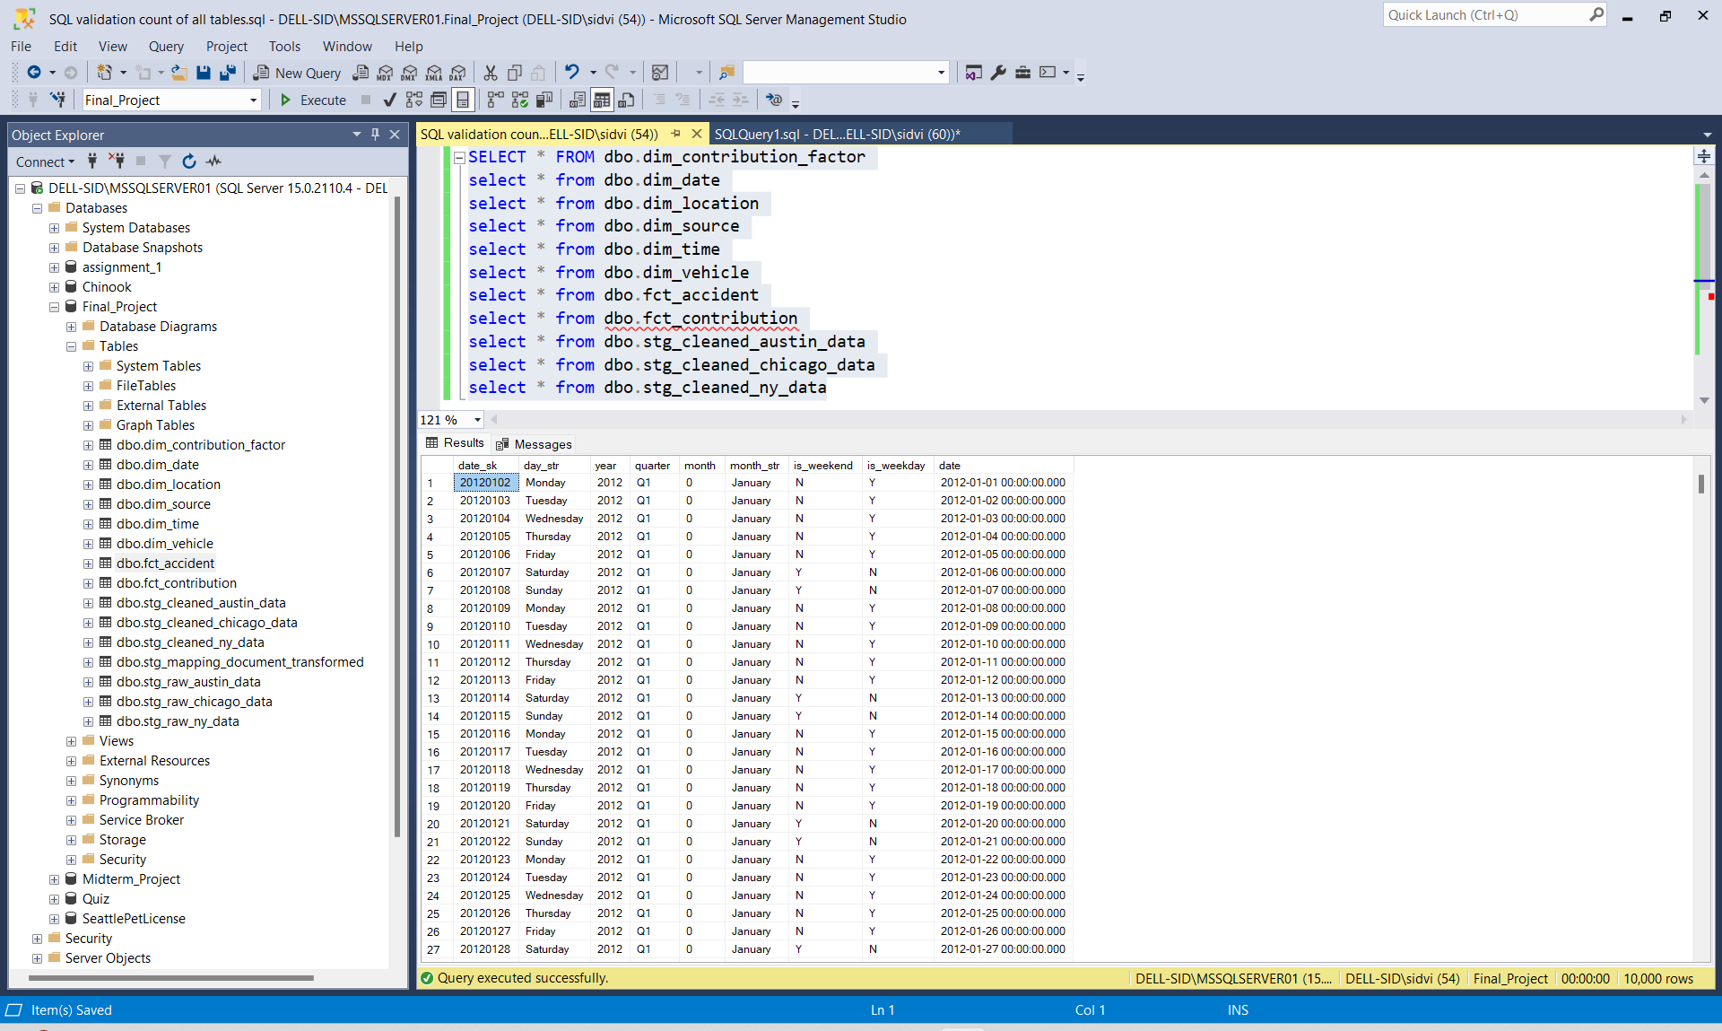

**Loading DimTime:**

1. Use a TRow generator to generate hours in integers from 0 to 23 and map the time period accordingly. Later we can lookup the data on “Hour” column in dim time and all the cleaned tables. Add columns DI_CreatedDate, DI_WorkflowName and DI_JobID to the table.

Complete Workflow Screenshot:

**Loading DimLocation:**

1. Select street names, latitude and longitude from all the cleaned tables. Unite them using a TUnite component and then extract only the unique set of values using the TUniqRow from all 3 combined. Add columns DI_CreatedDate, DI_WorkflowName and DI_JobID to the table.

Complete Workflow Screenshot:

**Loading DimVehicle:**

1. Select those columns from all the 3 cleaned tables which contain individual normalized records related to the vehicle involved in the accidents. Unite them using a TUnite component and then extract only the unique set of values using the TUniqRow. Add columns DI_CreatedDate, DI_WorkflowName and DI_JobID to the table.

Complete Workflow Screenshot:

**Loading DimSource:**

1. Select the column source name from all the 3 cleaned tables. Unite them using a TUnite component and then extract only the unique set of values using the TUniqRow. Add columns DI_CreatedDate, DI_WorkflowName and DI_JobID to the table.

Complete Workflow Screenshot:

**Loading DimContributionFactor:**

1. Select the column contribution_factor and contrib_factor_id which are derived by mapping the code values and descriptions from the mapping document. Unite them using a TUnite component and then extract only the unique set of values using the TUniqRow. Add columns DI_CreatedDate, DI_WorkflowName and DI_JobID to the table.
2. We have to implement SCD2 for this dimension so select output type as SCD2 table and do the following mappings.

Complete Workflow Screenshot:

**Loading FctAccident:**

Loading fct_accident using the cleaned Austin data:

1. Map the cleaned Austin data to a tmap. Take the lookups for all the 5 dimensions associated to the fact table. Join the columns rightly and apply a left outer join on all the unique matches. In order to calculate the measures, correctly analyze the data and implement the expressions by selecting the right attributes. Add a TUniqRow to select only the unique records(select comparison on all attributes to find a unique record.)

Complete Workflow Screenshot:

Loading fct_accident using the cleaned Chicago data:

1. Map the cleaned Chicago data to a tmap. Take the lookups for all the 5 dimensions associated to the fact table. Join the columns rightly and apply a left outer join on all the unique matches. In order to calculate the measures, correctly analyze the data and implement the expressions by selecting the right attributes. Add a TUniqRow to select only the unique records(select comparison on all attributes to find a unique record.)

Complete Workflow Screenshot:

Loading fct_accident using the cleaned NY data:

1. Map the cleaned NY data to a tmap. Take the lookups for all the 5 dimensions associated to the fact table. Join the columns rightly and apply a left outer join on all the unique matches. In order to calculate the measures, correctly analyze the data and implement the expressions by selecting the right attributes. Add a TUniqRow to select only the unique records(select comparison on all attributes to find a unique record.)

Complete Workflow Screenshot:

**Preview of the main fact table : fct_accident**

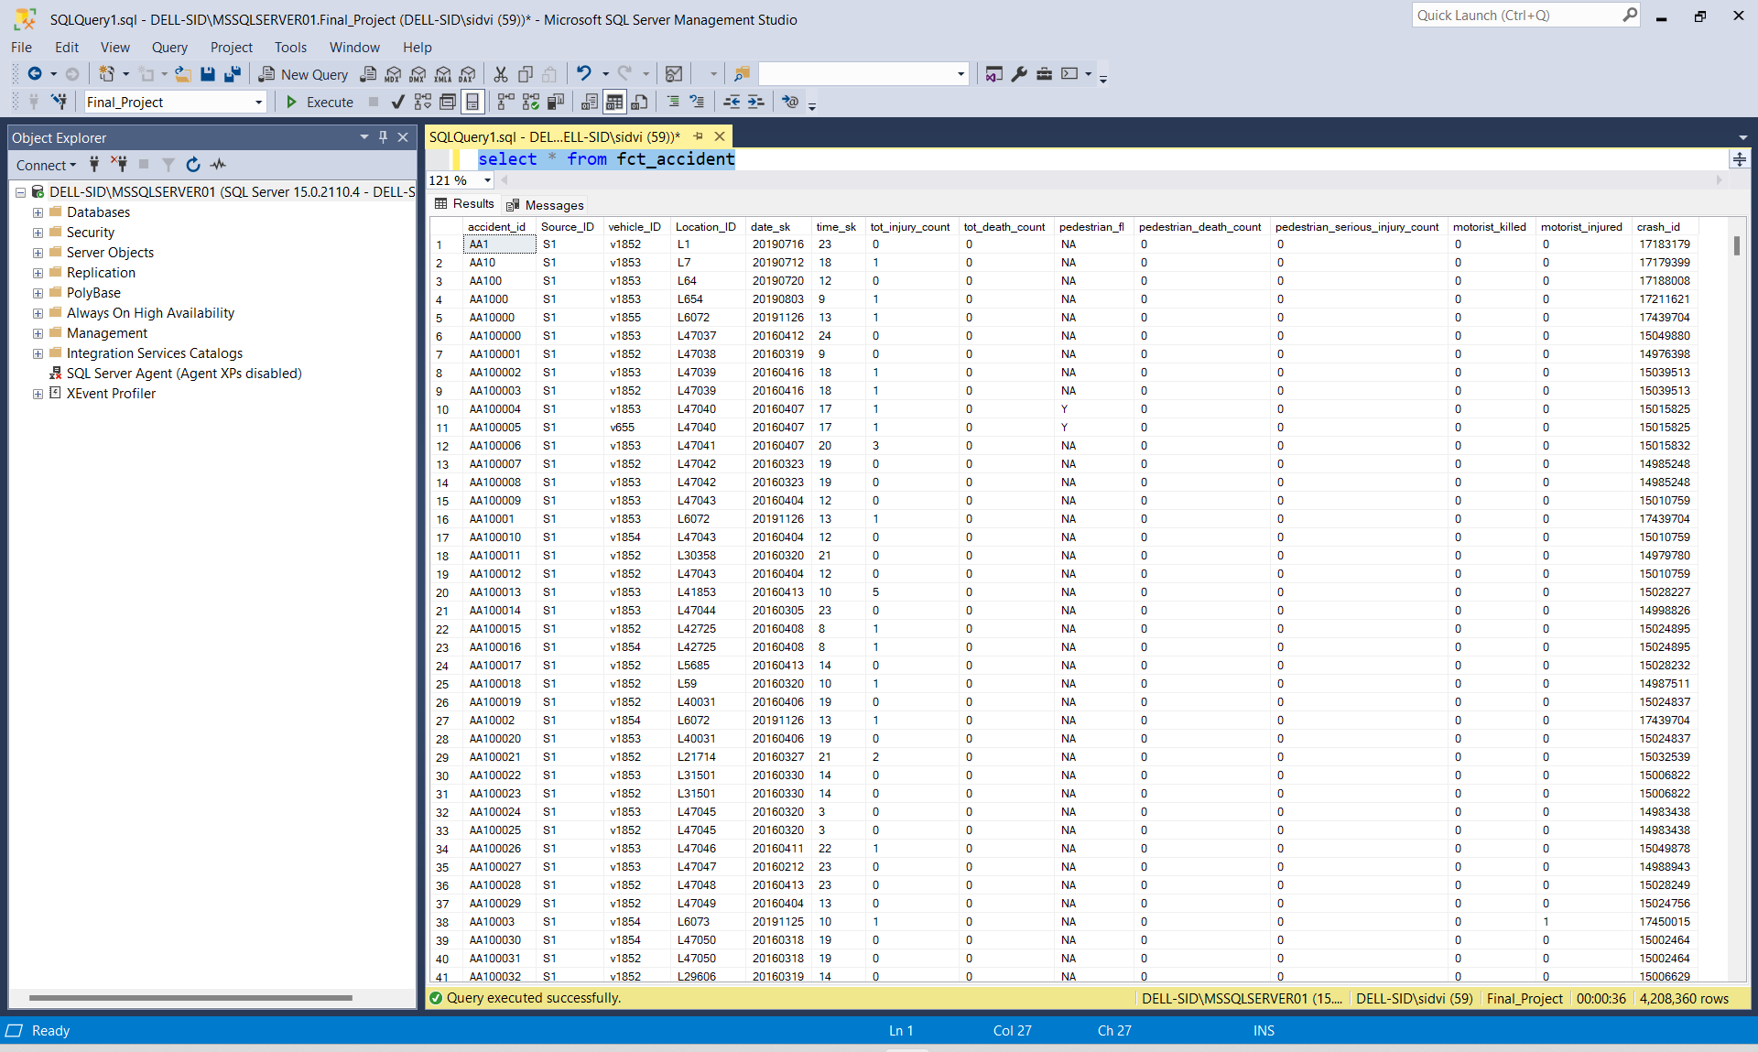

**Loading FctContribution:**

1. Map the cleaned data of all 3 tables to 3 distinct tmaps. Take the lookups for all the dimensions associated to the fact table. In this case, dim_contribution will be the only one dimension. Lookup the main fact table fct_accident as well. Join the columns rightly and apply a left outer join on all the unique matches.

Complete Workflow Screenshot:

**Preview of fact table : fct_contribution**

